REPORT ON LEARNATHON 2020

D Jasmine Joyline

4AL17CS024

VI Sem A sec

CSE Dept

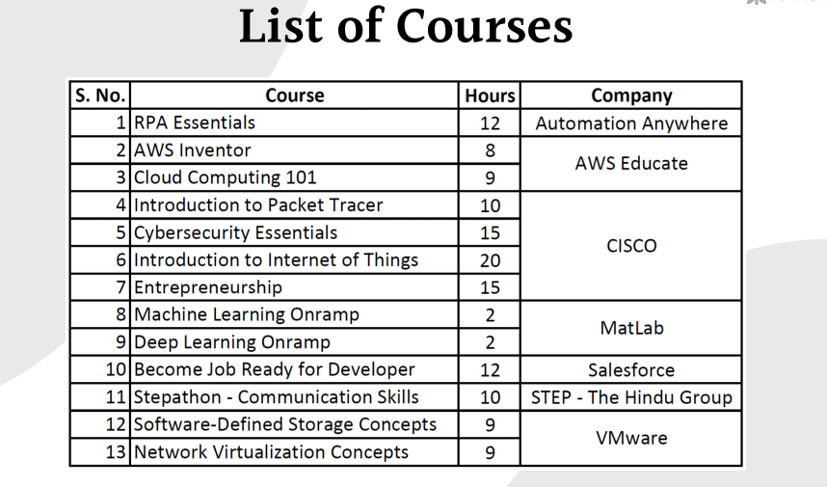

**1.RPA Automation**(Duration-14hrs)

RPA is for everyone. And the benefits of RPA span all industries and business units. Applying RPA for business process automation is limited only by the imagination and putting bots to work has never been easier, with a growing marketplace of ready-made, ready-to-deploy Digital Workers available on demand, requiring no specialized IT infrastructure.

Topics covered

1 Hello Bot: Introduction to RPA and Use Cases v11 3 hours

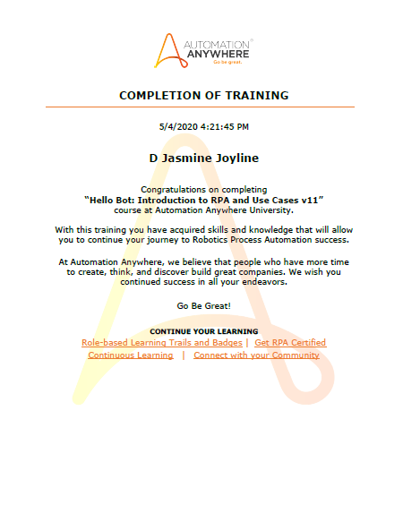

2 Build the digital work force 5 hours

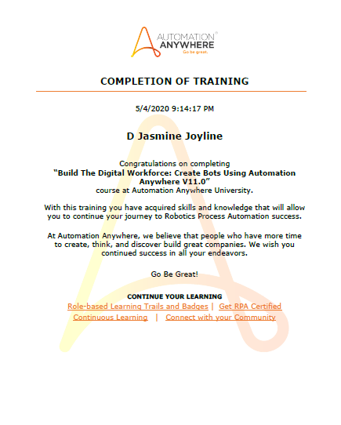

3 Storing and Manipulating Data: How to Automate Database-related Processes 30 mins

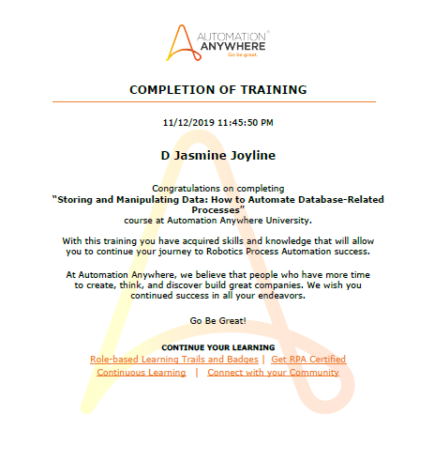

4 Automating Excel Operations: Methods to Work with Excel Workbooks 30 mins

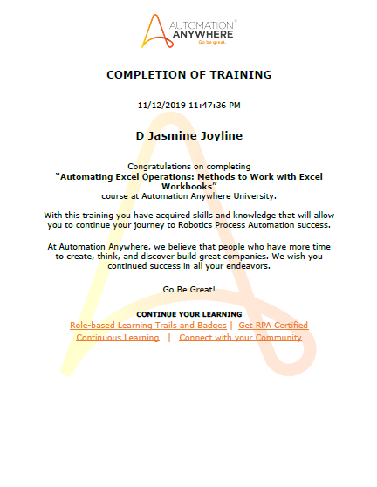

5 Working with PDF Documents: Methods to Automate PDF-Related Processes 30 mins

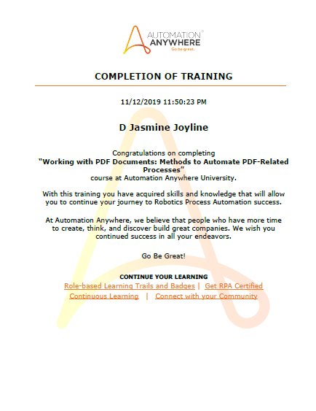

6 Automating Structured Data: How to Work with XML Streams 30 mins

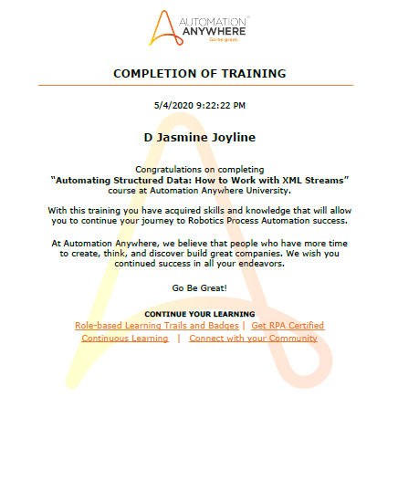

7 Automating String Operations: Methods to Manipulate and Extract Strings 30 mins

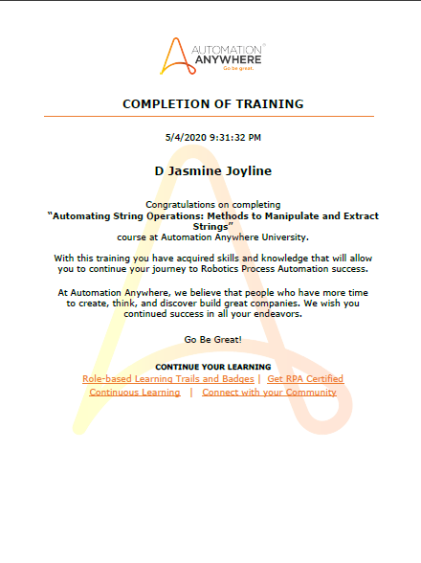

8 Communicating with Email Servers: Methods to Automate Email Messages 30 mins

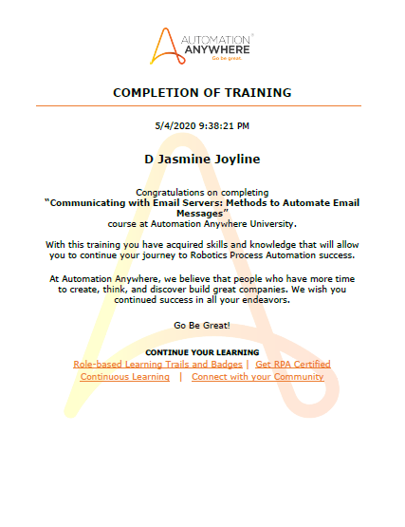

9 Communicating with Emulators: How to Automate Terminal Applications 30 mins

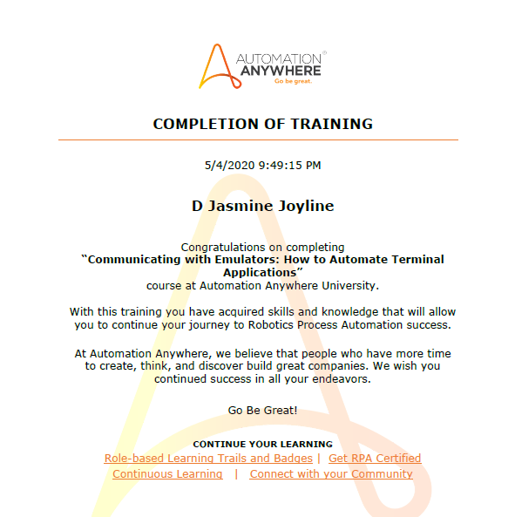

10 Unleash Your Intelligent Bots: Developing Cognitive Bots, driven by AI & Machine Learning 30 mins

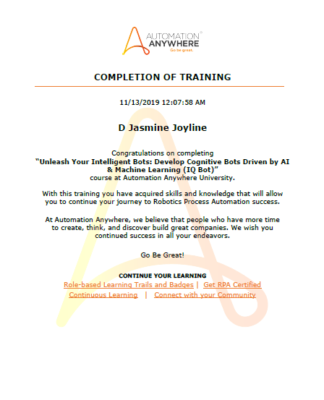

11 Bot Story: Where Automation Meets Analytics Using Bot Insight V11.0 2 hours Total Duration 14 hours

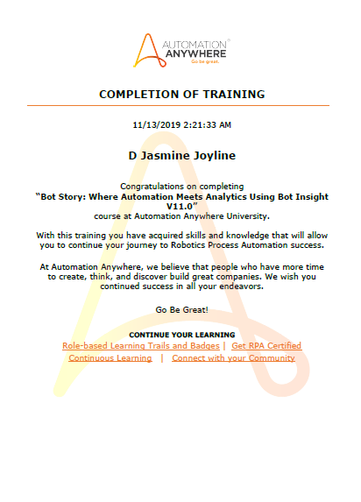

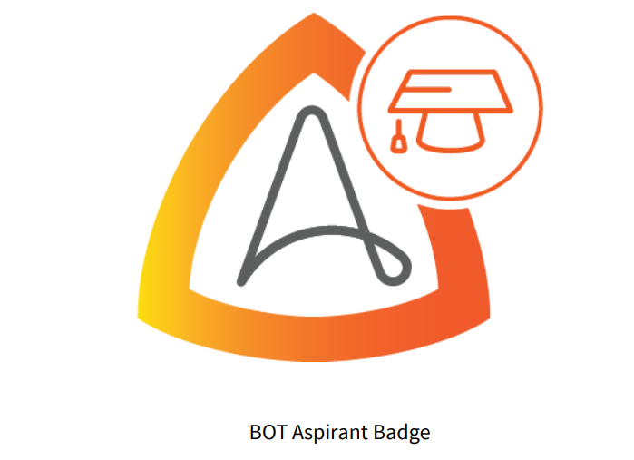

**2.AWS Educate**(Duration-17hrs)

The program is intended to induce self-learning and introduce basic cloud technology skills to all students. The program is organized exclusively for all institutions across India, where the students learn the modules online through self-instructed videos and exercises and prove their cloud learning skills. Start your journey on Cloud with AWS Educate.

Courses completed

**1Cloud Literacy** – Inventor 8 hours

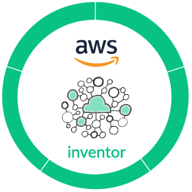

**2 Cloud Computing** **101** 9 hours

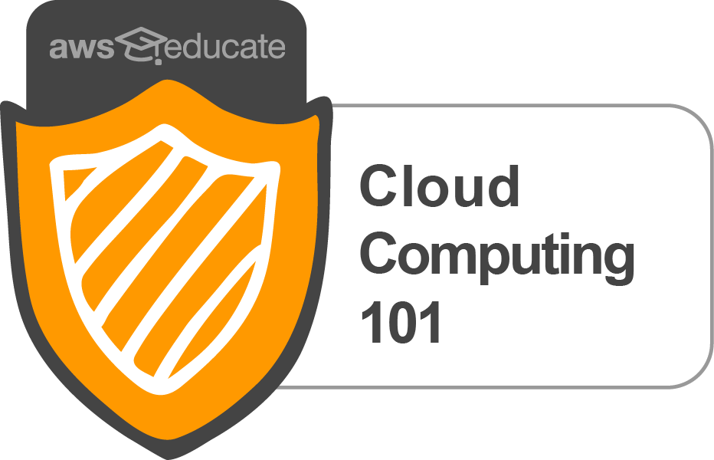

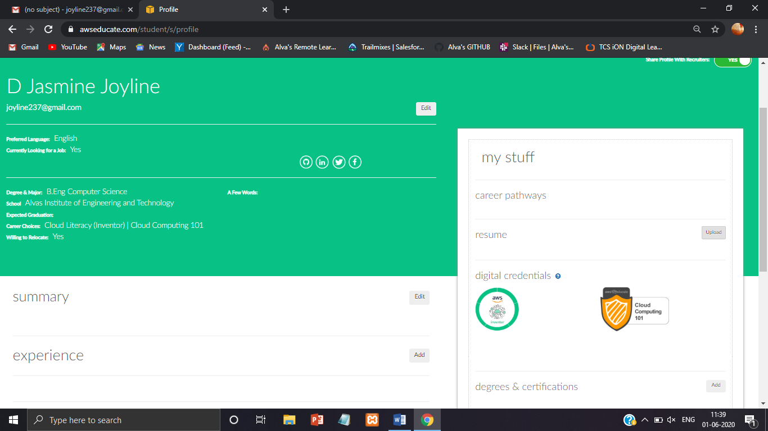

**3.CISCO Networking Academy** (Duration-60hrs)

Cisco Networking Academy is an IT skills and career building program for learning institutions and individuals worldwide. This platform helps you to practice what you learn, and become an IT professional. Here are few Beginner’s program, which gives the basic understanding of the respective course category.

Courses completed

**1 Introduction to Packet Tracer** 3 hours

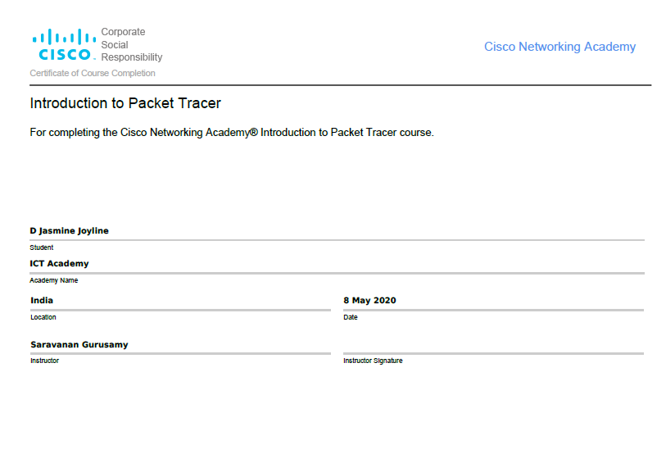

**2 Cybersecurity Essentials** 5 hours

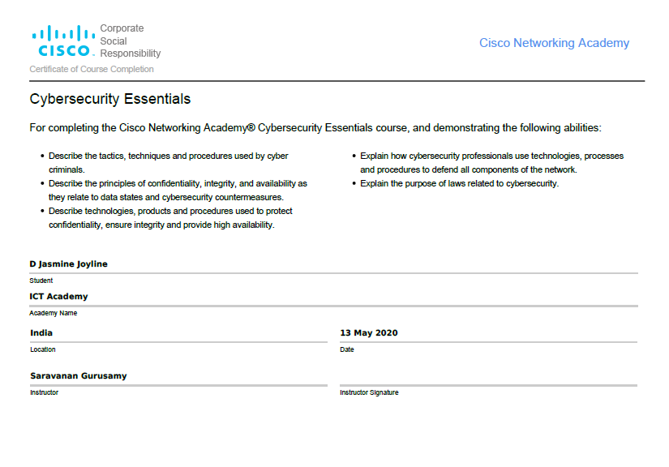

**3 Introduction to Internet of Things** 3 hours

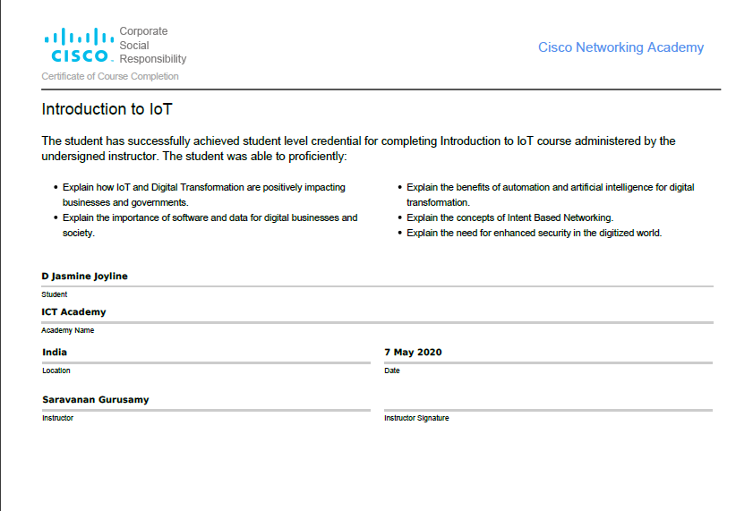

**4 Entrepreneurship** 5 hours

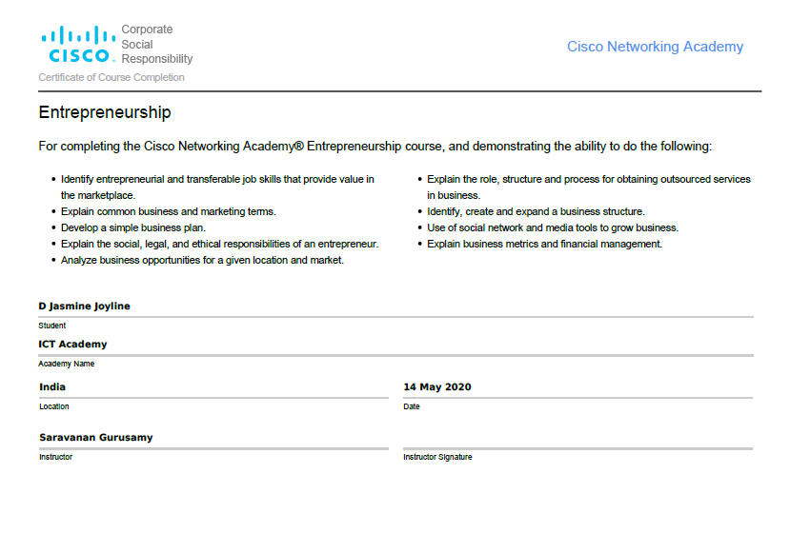

**4.MathWorks** (Duration-4hrs)

MATLAB offers this free course on Machine Learning and Deep Learning and provides an interactive introduction to practical methods on Deep Learning and Machine Learning. Here some of the topics that will be covered are classification workflows, importing and pre processing data and managing collections of image data. Advance your skills with MATLAB

**1 Machine Learning Onramp** 2 hours

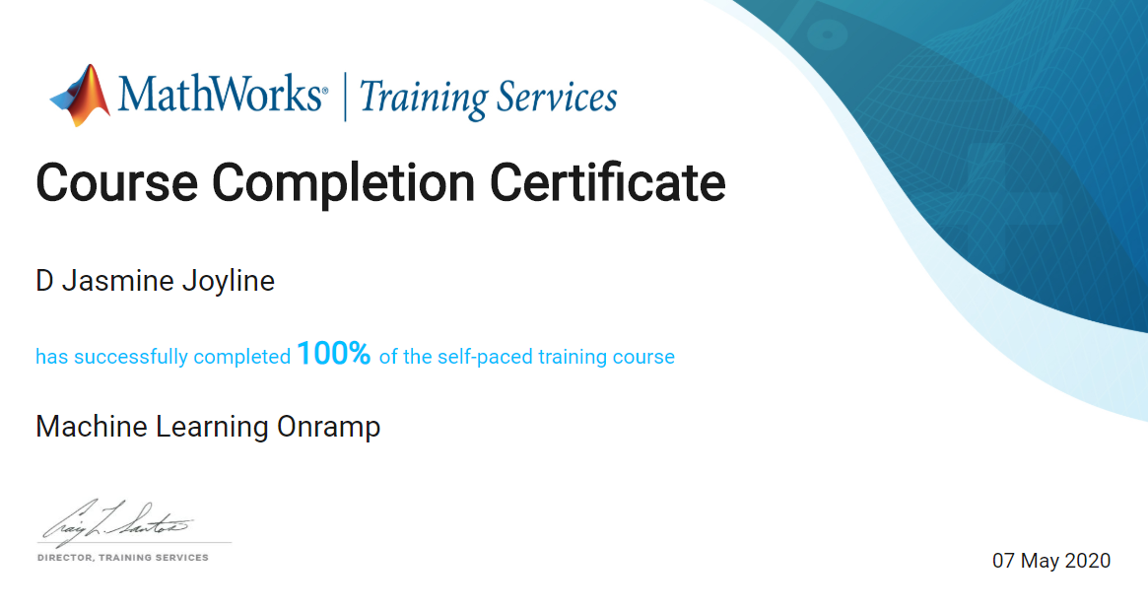

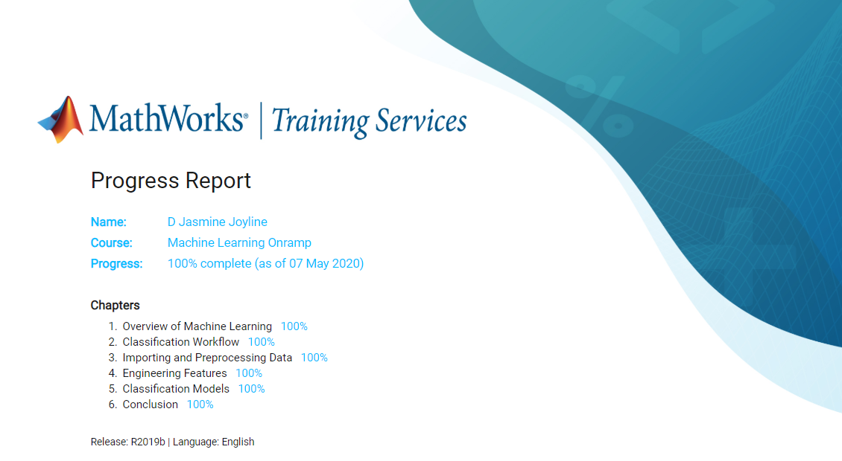

**2 Deep Learning Onramp** 2 hours

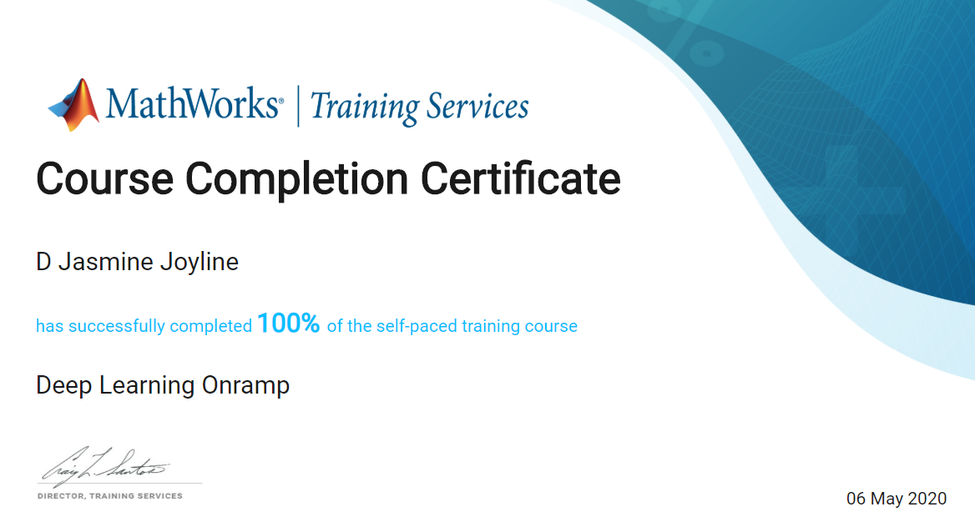

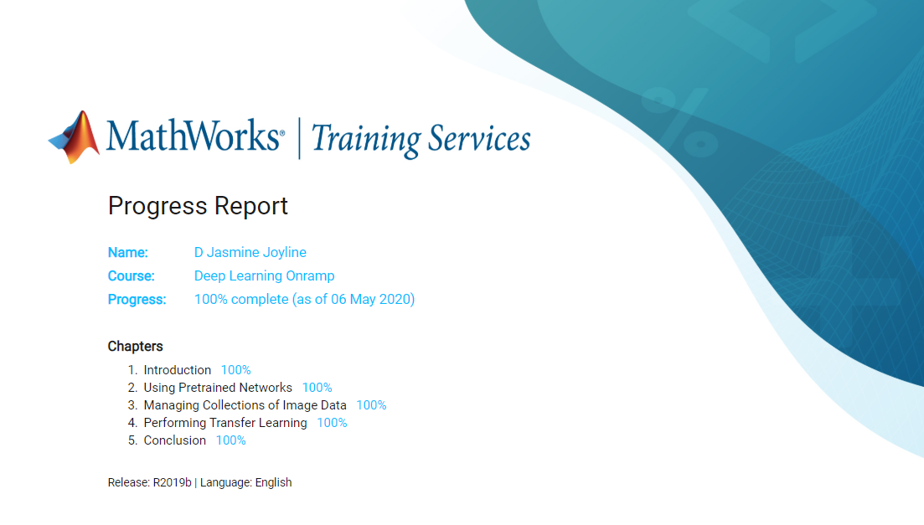

**5.Salesforce** (Duration-12hrs)

Salesforce Trailhead is a fun way to learn. Chances are, your next job will require Salesforce skills. This Trailmix is the initial step for the program "Become Job Ready for Developer". .

Modules covered

**1 Trailhead Basics** 15 mins



Learn the basics of Trailhead

**2 Trailhead Playground Management** 20 mins



Create hands-on orgs, practice your Salesforce skills, and complete Trailhead challenges.

**3 Salesforce Platform Basics** 50 mins



Get introduced to the platform, navigate use cases, and build custom functionality.

**4 CRM for Lightning Experience** 40 mins



Get started with Salesforce CRM and explore Lightning Experience

**5 Data Modeling** 45 mins



Give your data structure with objects, fields, and relationships.

**6 Build a Lemonade Stand App** 1 hour 30 mins



Build a simple app to manage a lemonade stand business. No code required.

**7 Picklist Administration** 50 mins



Choose the right picklist field for the job, manage picklists, and share picklist values.

**8 Formulas & Validations** 45 mins



Tailor your apps without writing code by using point-and-click logic.

**9 Data Management** 40 mins



Learn how to import and export data in Salesforce.

**10 Reports & Dashboards for Lightning Experience** 1 hour 50 mins



Visualize key business metrics in real-time using Lightning Experience.

**11 Build a Data Model for a Recruiting App** 1 hour 5 mins



Customize an app using clicks, not code, to give your recruiters easy access to key data.

**12 Create Reports and Dashboards for Sales and Marketing Managers** 1 hour 30 mins



Track key business information for your stakeholders with reports and dashboards.

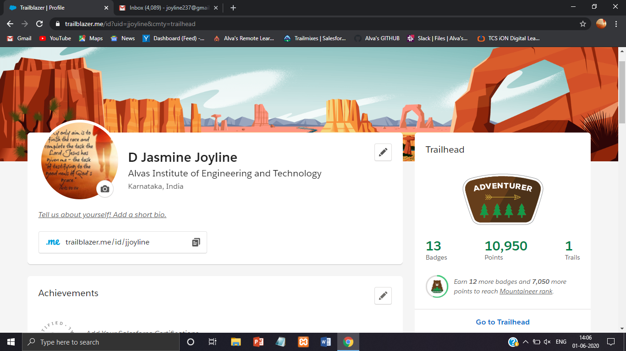

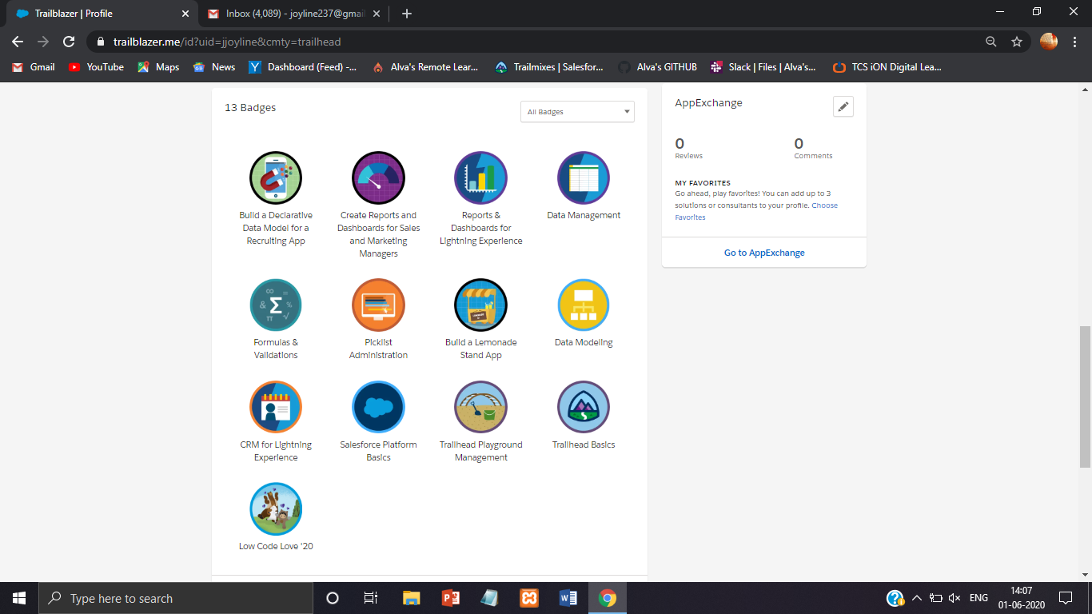

**6.STEP – The Hindu Group** (Duration-10hr)

This course develops the key communication skills namely reading, writing, listening and speaking skills as well as grammar and vocabulary. These video lessons use contexts involving practical, real-life situations and equip learners will skills need for day-to-day communication. Skill up your communication with STEPATHON.

Learning Modules

1 Reading

2 Writing

3 Listening

4 Speaking

5 Grammar

6 Vocabulary

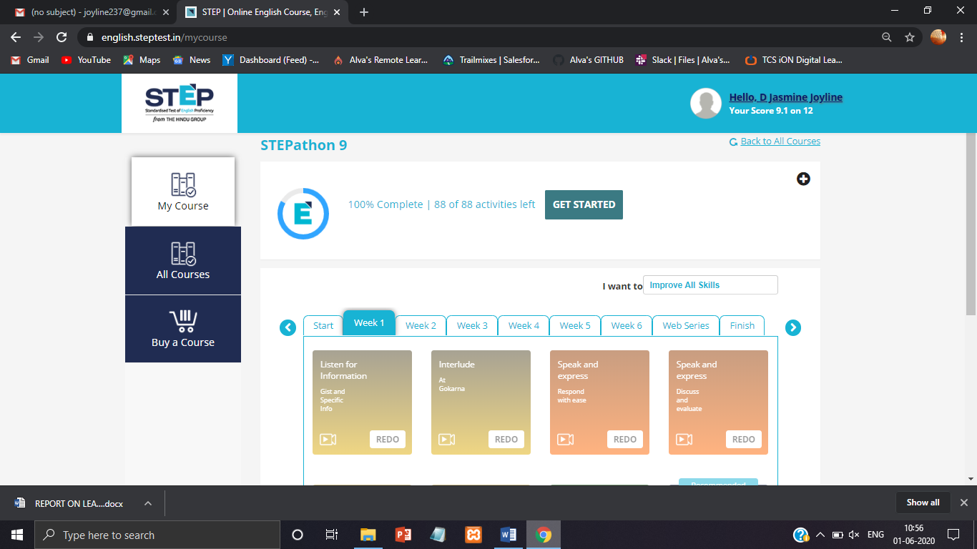

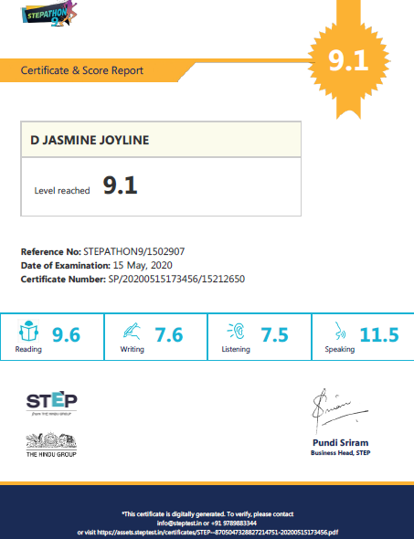

**7.VMware** (Duration-18hrs)

Businesses use virtualization to build large clouds to serve millions of people. Virtualization can be a powerful tool for anyone from public clouds to personal computers. You can use virtualization to run multiple operating systems on a single computer or backup your computer as a virtual machine. VMware IT Academy helps learners study cloud and virtualization.

Learning available from VMware IT Academy Courses

**1 Software-Defined Storage Concepts** 9 hours

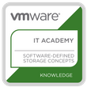

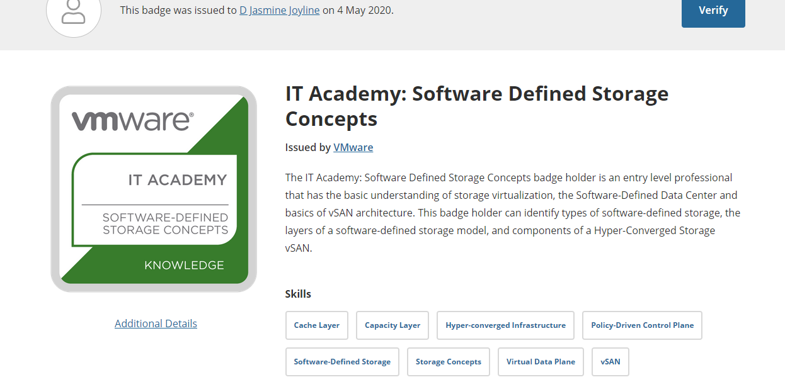

**2 Network Virtualization Concepts** 9 hours

